uDig Image GeoReferencing
IP Systems
February 24, 2009

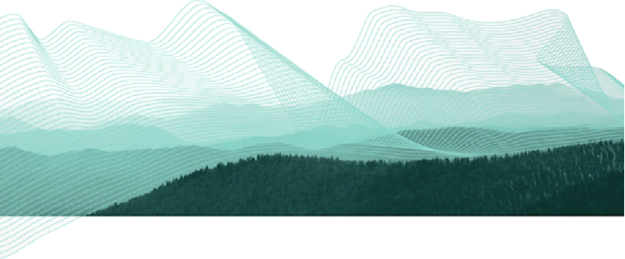


application Quickstart

Installing the application
Installing the uDig application is easy: simply unzip the udig_georeferencing.zip file and extract the files into a directory. Then double click on the udig.exe file to start the application.

Application Setup
Once you have installed and started the application, follow these steps to get started:
- First ensure that tiled rendering is turned off: From the Window menu select Preferences. Under the Rendering section make sure that “Use Tiled Rendering System” is unchecked. Click OK.
- From the File menu select New and New Map.
- Add a base map layer with a proper projection to the map by selecting Add... from the Layer menu and selecting your base map data.
Important: your images will be georeferenced onto the map based on the projection you have the base map layer set as. So it is important that your base map layer has a proper projection set.
- Once you have the base map loaded, pan and zoom around the map to the area you want to work with. You are now ready to use the georeferencing tools.

the GeoReferencing Tools
Once you have a map loaded with a proper base map layer, you can start using the georeferncing tools. These tools are listed under the toolbar that looks like a flat image being placed on the globe:

This toolbar includes 8 tools for loading and manipulating images overtop of your base map:
- Use this tool to load new images overtop of your map. These are plain image files such as jpg or png that you want to georeference onto your map. You can load multiple images and they will all float above the map.
- Use this tool to select an image floating overtop of the map. Only the selected image will be modified when you use the other image editing tools. This tool is useful for selecting a specific image when you have multiple images loaded overtop of the map. A selected image will have a red border around it.
- Use this tool to move the selected image around overtop of the background base map. Click and drag the mouse to move the image. Only the selected image with a red border around it will move.
- Use this tool to resize the selected image overtop of the base map. Click and drag the mouse to stretch the image. The closest corner you click will be stretched using the same aspect ratio as the original image. Only the selected image with a red border around it will be resized.
- This tool will delete the selected image. A confirmation box will appear before deleting the image.
- This is the tool you will use to place markers on your selected image and the base map to georeference the image onto the map. Only the selected image with a red border around it will be used for this function. You can place as markers as you wish on both the base map and selected image, with a minimum of 6 required.
- Once you have placed markers on the map and selected image, you can move and adjust them using this tool.
- After placing at least 6 markers on both the base map and selected image you can select this tool to execute the warp process. You will be prompted to save the resulting warped image as a TIF file and it will be loaded onto the map.

NOTE: when you have any of the above georeferencing tools selected, you can right-mouse-click on the map to rotate between them. This is an alternative method for rotating between these tools besides selecting them from the tool menu. This will only work when one of the georeferencing tools is currently selected (as it is within this tool group context that right-clicking works). One right-click will rotate the tool to the next one in the list. Right-clicking will skip over the Load Image, Delete Image and Warp Image tools as those tasks would typically disrupt the flow of the normal georeference editing tools. Those 3 tools must be selected from the tool menu as normal.

Georeferencing an image
The following steps provide an example of how to georeference an image overtop of your base map from start to finish.
- Load a base map layer with a proper projection. For this example we will use the PreIke.sid file which includes a proper projection. Select Add... from the Layer menu and choose Files. Click Next and browse to your sid file and open it.

- Zoom to the area of the map where we want to georeference the image:

- Now that the base map layer is loaded, we need to load an image overtop of the map. Click the Load Image tool and browse to the image we want to georeference onto the map.

- The image will be loaded ontop the bottom left of the map and set to a size that is 1/3 of the size of the current map. It is important to note that when this image is warped to fit onto the base map, the empty space left in the warped image will be transparent. However, if the initial image is not rectangular and has a background color that is not tranparent, that background color will still remain. If you want this background color to be transparent, edit the image in an image editor and save it with a transparent background before loading it into uDig. The 2 images below show an example of an image with a white background compared to one with a transparent background:

White Backgrond: Transparent Background:

- We need to move the image to a position that lets us place markers on both the image and the background base map. The image should already be selected, so select the Move Image tool.

- Move the selected image to an area of the map that allows us to see both the image and the part of the base map we need to work with:

- Use the Move Image and Resize Image tools until you are satisfied that you can easily see both the image and the base map. Then select the Place Markers tool:

- A popup window will appear with some instructions. Basically you need to place a minimum of 6 markers on both the image and the base map that line up with each other. You can place more than 6 markers for more accurate results. You can also check or uncheck the box to remove any previous markers before starting to place new ones (this is necessary because you can change tools to move the image and markers around and you may want to add more markers afterwards without removing the previous ones). When you are ready, click OK and to start placing new markers in the order of:
a). place marker 1 on the image
b). place the equivalent marker 1 on the base map
c). repeat until at least 6 markers are on both the image and base map:

- Continue placing markers until you are satisfied that the important areas are covered. You can also select the Move Markers tool to fine tune your marker placement anytime. When you are ready, select the Warp Image tool to begin warping the image based on your marker placement:

- After selecting this tool, the image will begin the warp process and a popup window will appear so you can save the result as a TIF file. Save the file and it will be loaded onto the map (removing the original image that was previously loaded):

- You will now have a warped image saved as a TIF file that is loaded on your map. If you are not satisfied with the result, you can try again starting from step 3. Remember that placing more markers (and placing them in important areas that you want to ensure line-up) will return better results.

